3.8 Introduction to TOGAF and Four Architectural Domains

**Implementation Timeline**

Figure_: Implementation Timeline

**System Architecture**

**Business Process Architecture**

FINANCIAL MANAGEMENT SYSTEM

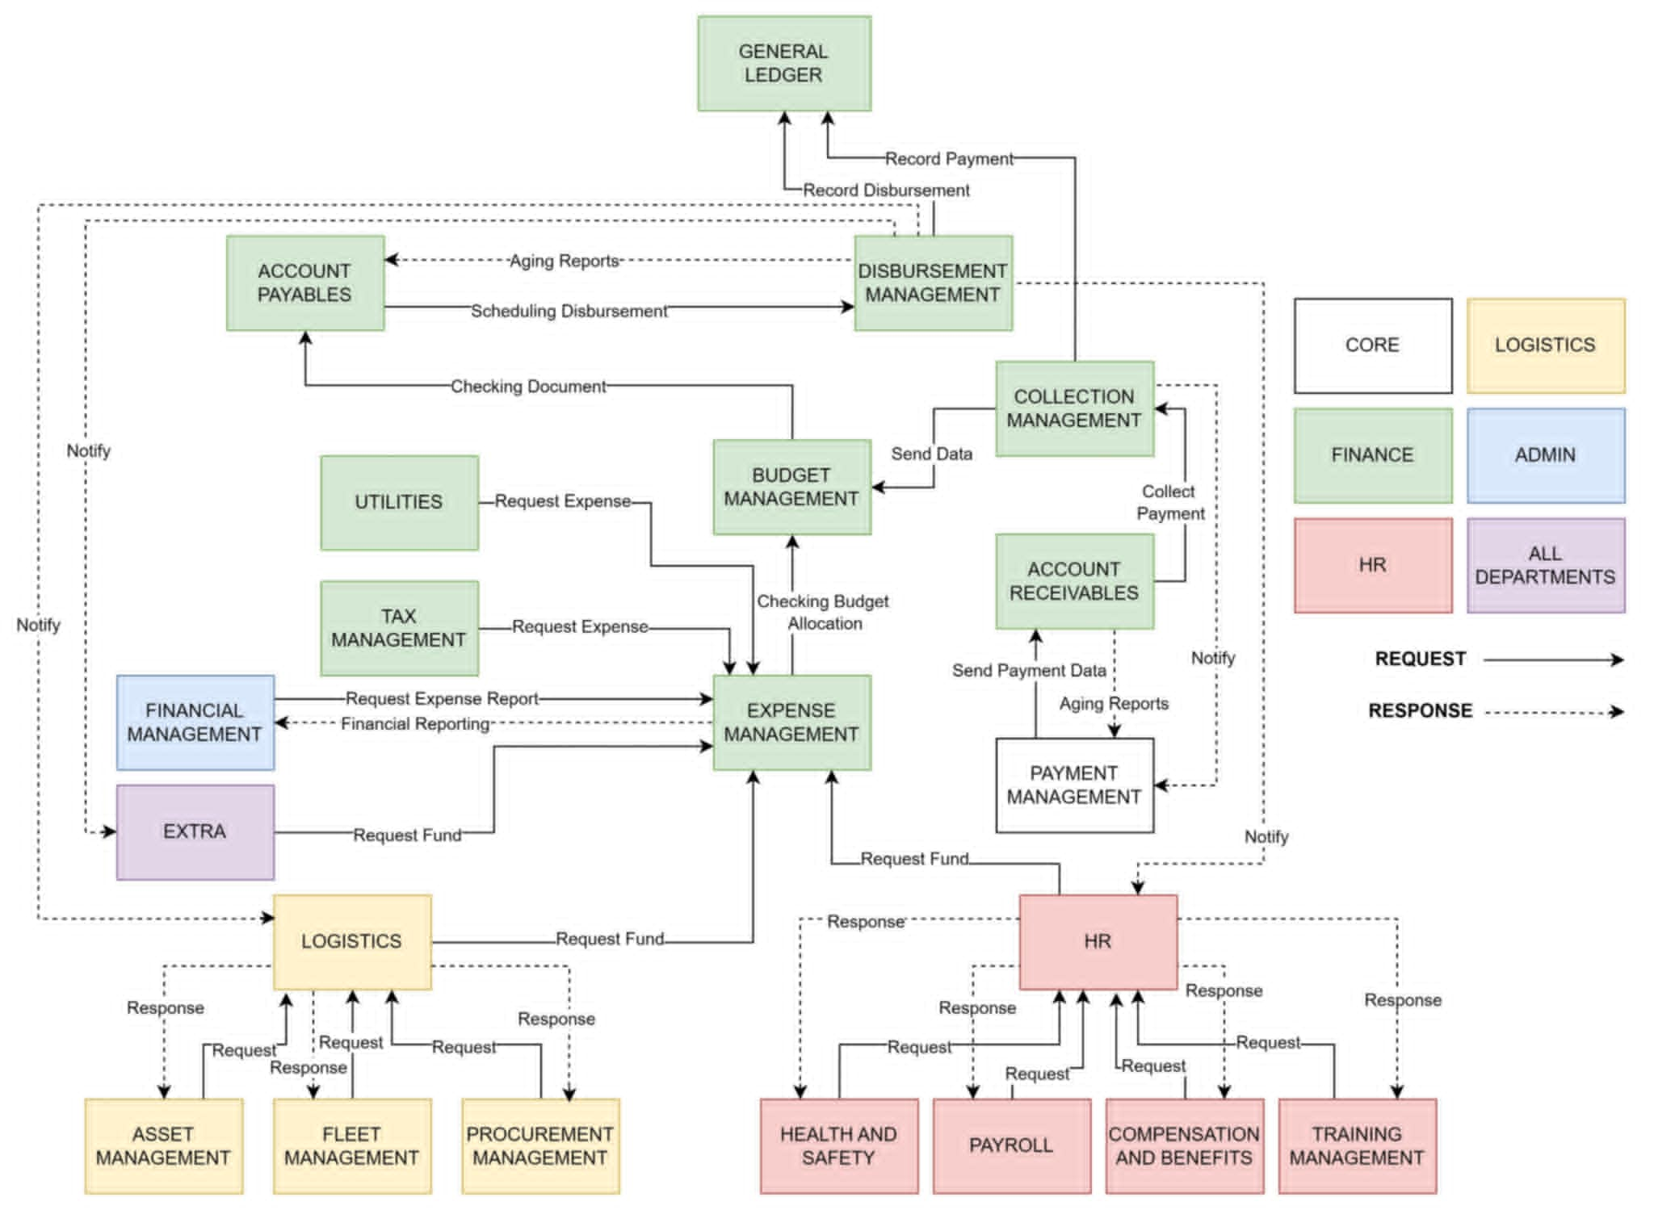(BUSINESS PROCESS ARCHITECTURE)

Figure__: System Architecture

**Application Architecture**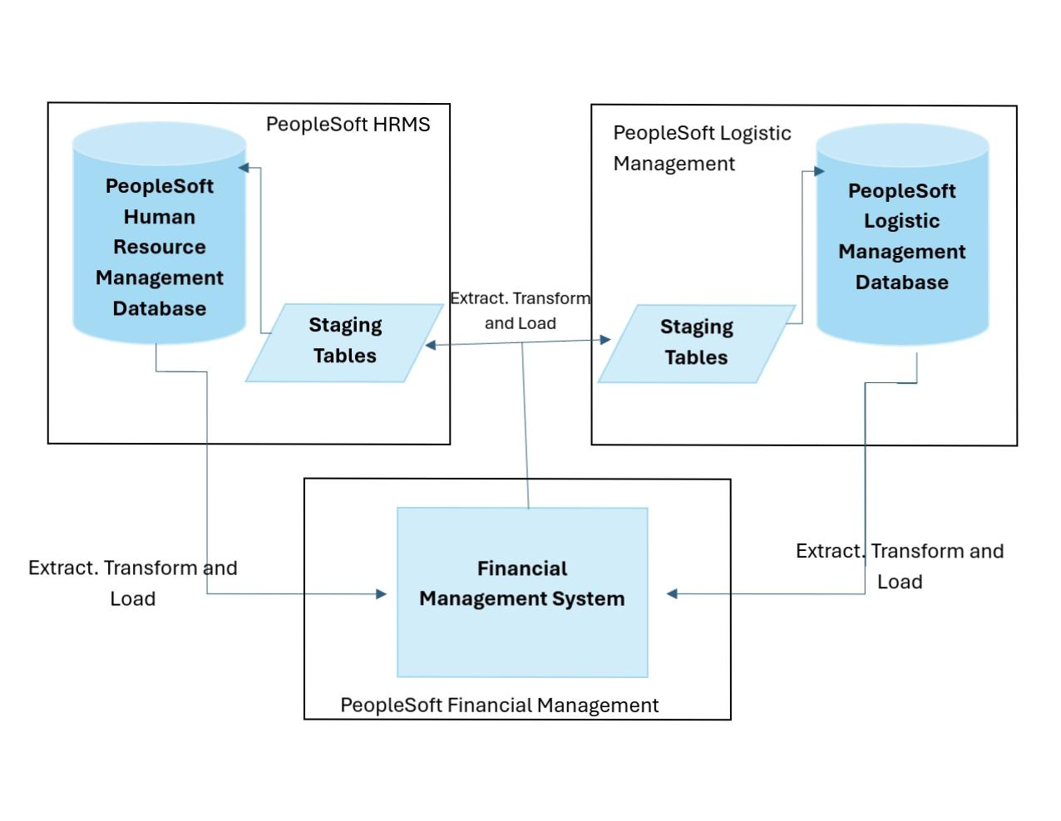

Figure_: Application of Financials

**Technology Architecture**

These are the applications we used in system development to create architecture, coding, design, analysis, programming language used, icons used and others that you can also see here.

|  |  |
| --- | --- |
|  | **MySQL** is an open-source relational database management system (RDBMS) that uses SQL to organize and manage data. It is known for being reliable, flexible, and is often chosen for web applications due to its ability to handle large-scale databases and deliver high performance. |
|  | **PHP** (Hypertext Preprocessor) is a popular server-side scripting language designed primarily for web development. It’s widely used to build dynamic and interactive websites, often working in combination with databases like MySQL. PHP can efficiently handle backend logic, interact with databases, and serve data to front-end users. |
|  | **CSS** (Cascading Style Sheets) is the language used to define the visual presentation of a web page, determining how HTML elements are displayed in terms of layout, colors, fonts, and overall design. It separates content (HTML) from design, allowing you to create aesthetically pleasing and responsive web interfaces. |
|  | **HTML** (Hypertext Markup Language) is the standard language used to create and structure content on the web. It provides the foundational framework for web pages by defining elements such as text, images, links, forms, and multimedia. HTML works hand-in-hand with CSS (for styling) and JavaScript (for interactivity) to deliver fully functional and visually appealing web applications. |
|  | **JavaScript** is a powerful, dynamic programming language used primarily for creating interactive and responsive elements on web pages. It works alongside HTML and CSS to build dynamic web applications, enabling real-time updates, user interaction, and advanced functionality without needing to reload the page. |

Table_: Technology Architecture

Development

Development

Development

**Development**

**Design**

**Analysis**

Testing

integration

Development

Design

Analysis

Deployment

Deployment

Design

Analysis

Planning

**DEPLOYMENT**

**TESTING**

**DEVELOPMENT**

**DESIGN**

**ANALYSIS**

**PLANNING**

Core Management

Admin Management

**Admin Management Database**

**Core Management Database**

E

**Financial Management System**

**Staging Tables**

**Staging Tables**

Human Resource Management

Extract. Transform and Load

Extract. Transform and Load

Extract. Transform and Load

**Logistic Management Database**

**Staging Tables**

Logistic Management

Financial Management

**Human Resource Management Database**

**Staging Tables**

Extract. Transform and Load



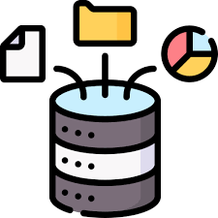

**Database Backend**

**Web Server**





**User Frontend**

**(HTML, CSS, JavaScript)**

**This is where the user interacts and input the data with the Application/Website.**

**(PHP, MySQL, Java)**

**The part where the server processes data and logic.**

**(MySQL)**

**The part where the system stores and manage data.**

**Response**

**Fetch Delete**

**Insert Update**

**Request**



**Web Backend**

**</>**

**</>**



**Request**